Manual

External Auditor’s Manual for the Logiqc platform

The LogiqcQMS Accreditation evidence reports
The LogiqcQMS Accreditation Register is a self-assessment tool that supports the organisation to create an evidence report against standards requirements by linking relevant evidence in their system (e.g. policies) to the associated criterion and requirements of a given standard.

For Auditors
Auditors can use the LogiqcQMS for the purposes of reviewing how an organisation complies with the requirements of standards.
The organisation can provide auditors with a username and password to access their system to review their self- assessment and evidence.

For organisations
Organisations can use the LogiqcQMS Accreditation Register during external audits as a means of providing the auditor with easy access to evidence of compliance with given standards. The evidence report for more than 50 Australian, NZ and international clinical and quality standard can be setup in the LogiqcQMS platform.

LogiqcQMS platform overview
The LogiqcQMS is a total quality and compliance management solution, customised to relevant quality standards, that drives business transformation and growth.
LogiqcQMS can be configured for a single purpose or as a fully integrated platform to support a wide range of management processes including:
- Accreditation self-assessment and evidence reporting
- Risk and hazard management
- Document control
- Contract and compliance management
- Safety (incidents and complaints)
- Internal audit and Improvement
The LogiqcQMS is a cloud-based software platform used by Day Hospitals, Community Service Organisations, GP practices, and PHO’s across Australia and New Zealand.

Overview
The organisation’s evidence report lists the criteria in the given standard.
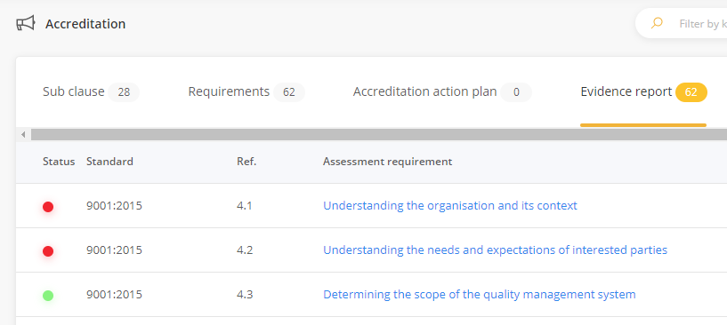

Clicking on the assessment requirement link will open a detailed assessment report from the organisation including a description of how the organisation complies with the criterion and hyperlinks to relevant evidence held in the organisation’s LogiqcQMS such as documents (policies and procedures), records and certificates etc. In addition, the organisation can attach links to scheduled processes such as audits and compliance tasks.

Instructions
- Log in with the instructions and credentials provided by the organisation
- Select Accreditation from the navigation panel
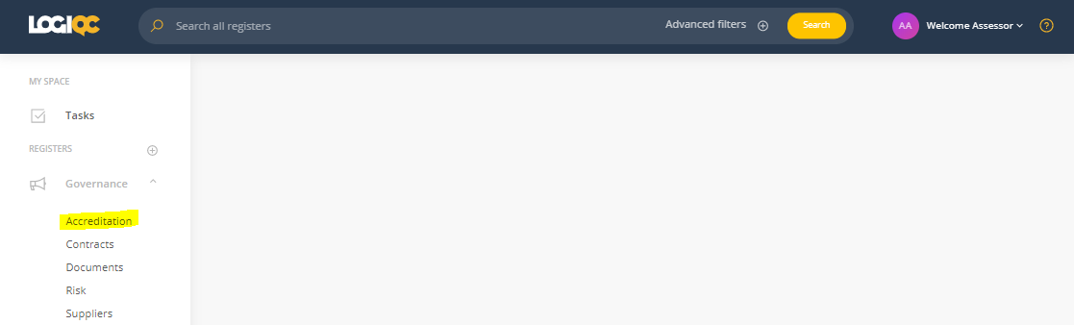
- Click on the Evidence report tab
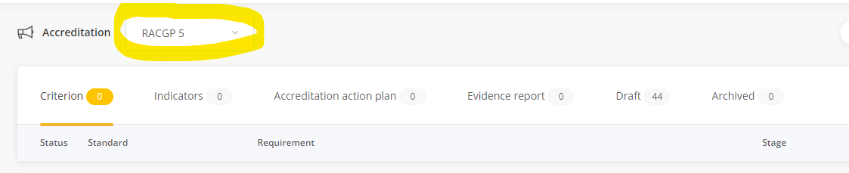Note: The organisation may have more than one standard activated in their QMS. If the correct standard is not displaying, select the correct standard from the drop down menu.
- Click on the specific assessment requirement to review
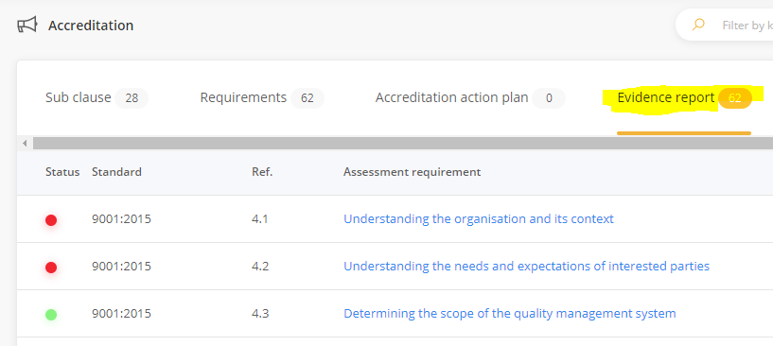

- Review the organisation’s self-assessment and evidence
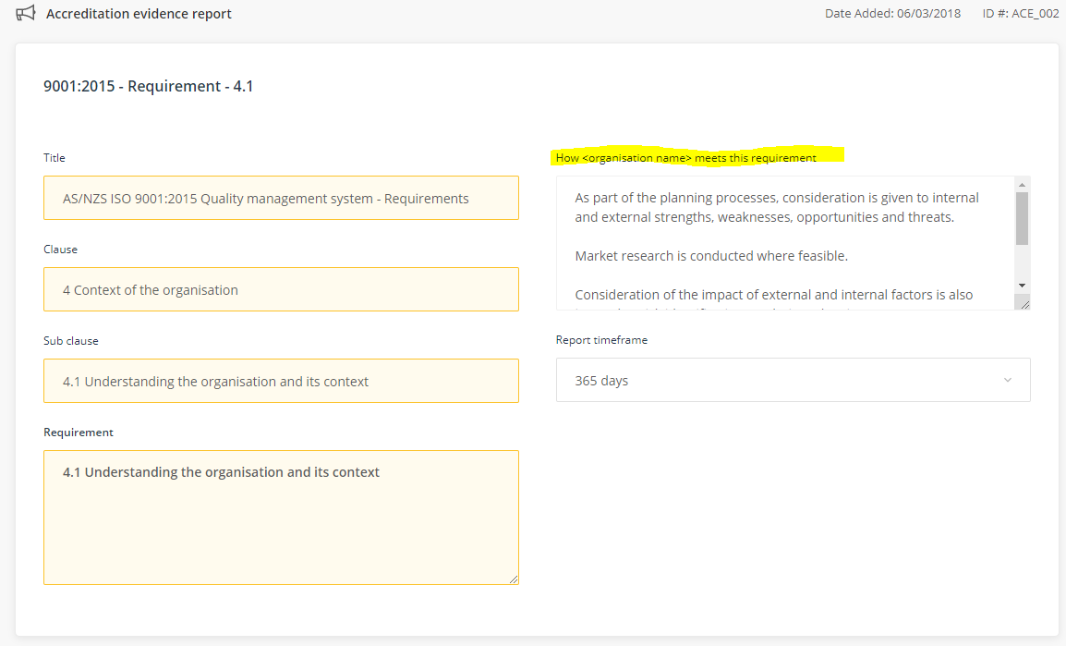

- Scroll down to review all the evidence relating to the criterion that the organisation has attached. This may include accreditation/improvement actions that open or completed as well as approved policies being managed in the organisation’s system.
Expand each ‘evidence panel’ by clicking on the ‘plus’ (+) icon. Click on the blue ID# link to view the evidence item.
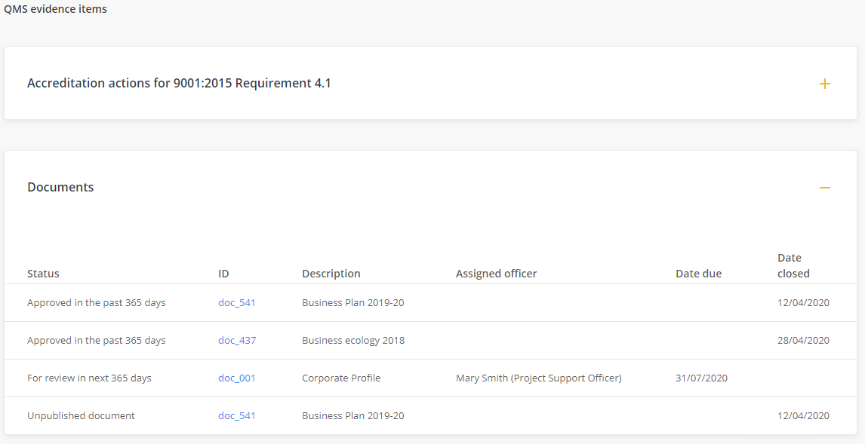

Evidence from other registers in the organisation’s QMS, such as audits, identified risks and compliance tasks, will also be displayed on this page in separate expandable panels.

Auditor training
A free 30-minute Auditor training session is available by contacting training@logiqc.com.au

Contact
Any questions can be directed to the Customer Success team, at customersuccess@logiqc.com.au



AU +617 3216 0335 NZ 0800 002 280 E: info@logiqc.com.au W: logiqc.com.au

